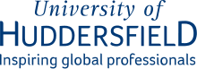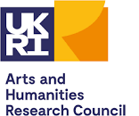

Notes and learning from WY ICS Building creative consortium workshop

WHAT DO WE UNDERSTAND BY CREATIVE, CULTURAL AND COMMUNITY ASSETS?
Creative assets include… creative thinking (ideas, innovation, imagination, creative solutions), infrastructure, research and training.
Cultural assets include… intangible things like values, traditions, beliefs, history and heritage, stories, language, generational knowledge and things we have in common, as well as tangible things like heritage venues, cultural spaces and food.
Community assets included spaces and local facilities like hairdressers, shopping centres, village shops, supermarkets, community centres and village halls; as well as modes of communication like community newspapers and whatsapp groups. Other community assets were around an ability to access… access to grants, shared ownership and free access. Health, relationships, community support and a sense of place were also seen as a community assets.
Creative and cultural assets include… spaces for creativity like artist studios, museums and galleries, connectors and time.
Cultural and community assets include… libraries, pubs, social clubs, NHS services like GP clinics and blue and green spaces, identity and belonging.
People, artists and creative practitioners, and knowledge were in common across all categories, as well as voluntary and community organisations, physical venues/spaces and online communities.
A common theme across all these different assets was the importance of people (relationships, values, community spirit, knowledge, networks) and spaces for them to be in, as well as other infrastructure and amenities. Questions were raised about who has control of the assets and whose voices are heard/not heard in this context.
WHAT WE KNOW WORKS WELL?
Enabling empowerment and personal responsibility for their own health
Accessible, localised spaces and inclusive / obvious pathways.
Importance of follow up and following through.
Sustainable and consistent (not funded as one off projects).
Allowing time to develop relationships with communities, establishing trust and being “non-judgmental”.
Services/activities are co-designed and iterative.
It generates tangible assets e.g. a creative output that participants can feel proud of.
Being flexible and responsive to context rather than outcome first.
When systems are responsive to change.
Building capacity and cross-sector learning (e.g. secondments going both ways).
WHAT IS IMPORTANT WITH HOW WE THINK ABOUT CREATIVE PROVISION?
There needs to be shifts in thinking… in understandings of creative and cultural practices and organisations and a culture change needed about the value of creative health and the non-medical model. We need to focus on what is important for the community and take a person-centred/community-centred approach, while recognises that people in different communities may have different creative/cultural assets in mind. We need to recognise that this is complex work but work is still needed to make the case for funding.
Different types of provision are available… that support different manifestations of creativity. Including online provision and hybrid offers through which we can pool resources, while recognising that different environments (including online) shape different experiences.
Networks, visibility and communication… we need to articulate what the full spectrum of practice in creative health looks like and join it up, rather than developing something new. We need to widen knowledge amongst public practitioners and create networks of opportunity for people, with both local and region wide offers in creative health as well as widening international networks for learning and exchange.
There are existing systemic problems including… too much pressure on GPs, not enough time, unsustainable funding, siloed organisations and inequalities in service provision across areas. We need to make sure that we give voice to different population groups and ensure that organisations’ are supported to participate in partnership working. Organisations are being asked to bridge a gap without supportive provision, they need help to train the expertise/workforce.

HOW DO WE MEASURE SUCCESS?
Questions were asked about what we mean by success… Why always a success, how do we learn from failure? What are the successes without measurement?; Do we always need to prescribe criteria?
There is not one measure of success… we need to map what is happening for a person and their experience and the intangible successes and values of engagement that have an impact in someone’s life. However consistent data dashboards on Creative Health approaches can help to provide medical professionals with more information and choice, there is an opportunity to consider how this might work at an ICS level.
We need to recognise complexity and nuance… Creative organisations are responsive to the nuances of lived experience and different kinds of experience. We need to understand causation, asking why things are happening in a particular way and better understand the person and the complexities of living a life. We also need to recognise the complexities of medical and non-medical interventions in the development of a care package for a person.
“Success” can be affected by external factors and wider infrastructural issues… e.g. housing, finances or the environment we live in that become barriers to access or impact on your ability to do stuff.
As such, “success “is context specific but can be when…
It builds people’s social/cultural capital, friendships, and networks
It developed trusting and meaningful relationships.
The creative process sparks something within a person
Service users know that this is important to them and start to make time for their own self-care.
It opens up new ways of seeing and understanding
People feel listened to and part of the process
It generates a sense of achievement
People enjoy it and come back again (repeat attendance)- people become volunteers
It facilitates learning and participation to produce and contribute to new knowledges
It provides accessible, comfortable and welcoming spaces for people to go to.
People feel like they have choice.

WHAT ARE THE UNDERLYING CAUSES OF HEALTH INEQUALITIES
In general it was noted… the social determinants of health and structural/social injustices. All the strands within the Equality and Diversity Act.
Including… structural racism, class, economic poverty and deprivation and income inequality. Trauma in communities. Communities being disempowered and disenfranchised. Health inequalities can be generational, stemming from family histories, multigenerational trauma and multigenerational health impacts.
The places where we live … poor housing and poor living environments, lack of access to reliable and disability friendly transport, access to employment and education, the loss of local employment opportunities, lack of green spaces and lack of community/sense of identity/belonging, feelings of safety both physical and psychological. This can be historic and political e.g. the loss of local employment opportunities and regional disinvestment (North/South divide).
The places where we work… local industry e.g. asbestos, cancer and lung conditions.
Being able to access services can depend on… how you see yourself or how others see you, or a lack of visibility; whether or not yourhave cultural capital and awareness of what is on offer. Culture or language can be barriers to access. Access to service driven by tenacity, rather than need. Your distance from necessity and whether you are able to meet basic needs. Whether there are services provided that you can access, recognising an inequity of service provision in some communities.
Your capacity to access services can be affected by… previous negative experiences, loneliness, lack of friend and family support networks, personal motivation and personal mental health, stress, addiction, homelessness, neurodivergence and age.

HOW DO THESE PLAY OUT IN PEOPLE’S LIVES
Through social issues… crime; teenage pregnancies and abortions; social isolation.
Through health conditions… CVD, obesity, Type 2 diabetes; Mental disorders; Suicide; shorter life expectancy, living with long term health conditions and caring responsibilities; Long-term physical and mental health conditions;
Through unhealthy habits… unhealthy diet, smoking, addiction, inactivity and chaotic lifestyles.
Through unhealthy working conditions… working long hours/multiple jobs/ no work-life balance/zero hour contracts; limited opportunities (revolving cycle of poverty).
They sustain geographical inequalities e.g. rural isolation.
They affect relationships, trust and connections; building fear and mistrust.
They generate feelings of fear/lack of safety of different kinds; Being in survival mode; pressure and stress.
They eat away at confidence and esteem on an individual and community basis resulting in a lack of social and cultural capital.
They create barriers which affect people’s ability to access and change creating a downward spiral of deteriorating physical and mental health, self-neglect, low confidence and increased isolation which can impact on others, including the wider family and affect people’s ability to go to places and participate.
When people are not involved or considered in the design of services people don’t feel that their experience is honoured and respected.
When people are struggling to meet basic needs, we need to take account of the distance that people have to travel to get to the point of being able to access culture and creative provision.
There is a lack of trust, lack of opportunity, lack of safe and welcoming spaces and a lack of expectations of support. There may be relevant, care and support services but they do connect with those with health needs.
This can put pressure on delivery organisations where individuals with unmet needs develop trusting relationships with organisations/services the demand for services may overwhelm small organisations/individuals.

WHAT ARE THE ISSUES AND COMPLEXITIES WITH HEALTH INEQUALITIES THAT WE NEED TO RESPOND TO?
Individual, societal, and governmental responsibility have different complexities and issues.
We need to talk about and understand personal issues; look at the whole person; be trauma informed; work with partner organisations and community organisations that have understandings of the condition and include people with lived experience.
We need to raise awareness about the societal impact of health inequalities (look at the book The Spirit Level) and on a local level make sure that people know where to go for help. We need to recognise the role of education and aspiration.
Funding needs to be sustainable, long-term, and equitable in all areas. Time writing bids needs to be factored in. Funding for ‘health’ and ‘creative health’ interventions should not be in opposition.
Equity of access for those who are ‘time poor’ and facing competing priorities. There are ‘built in’ inequalities /barriers e.g. can’t call GP at 8am if doing the school run. We need to recognise the amount of effort it can be to engage.
We need to ensure that we are identifying who has need and that there is access for those that need most. We need to co-produce with communities at the street level.
People with complex multiple health conditions may have had multiple assessments – means testing, diagnosis, triage etc., without receiving support.
Inequalities are growing and disparities are topographic- we need to understand what they are in West Yorkshire. Some contexts/areas will have better infrastructure than other areas or neighbourhoods e.g., transport, accessible venues, digital exclusion, availability of services.
We need to create ‘psychologically safe’ places to access provision, creating space where people feel valued.
Bering people together around shared experiences and working person-to-person, while we need to recognise that it takes time to break down barriers and build trust with people.

IDEAS FOR HOW CCC ASSETS CAN PLAY A GREATER ROLE IN IMPROVING HEALTH
Poster 1
Pic1: Can start anywhere, Evolutionary, no straight path, complex and organic
Pic 2: Supporting individuals to make space (take time) for creative interventions
Looking after and protecting our creative cultural and community assets
Supervision /support for health and wellbeing of creative health staff and workforce
Pic3: Partnerships/multi agency; collaboration/ coproduction; cocreation/cross sector
Necessary, urgent, common goals/priorities
Recognise human needs of stakeholders
Welcoming spaces suited to purpose
Transitional spaces – toilets, car parks, tea and lunch breaks for unstructured connection and developing trust and understanding
Outliers included and supported
Pic4: Fundamental needs met by creative solutions
Fundamental need of (provider) for variety / fun/play

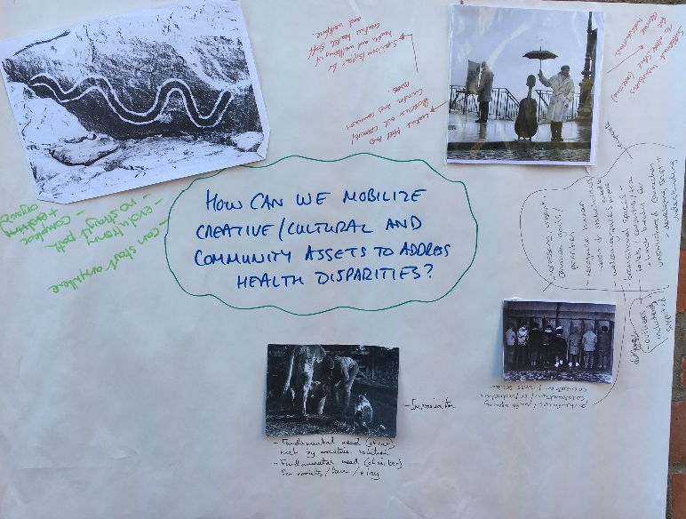

Pic 1: Caught in the machine, contained, move from a maintenance model to a recovery model➔
Pic 2: more freedom, more choice, more health and well-being -> Liberation:
Pic 3: I come from a community, find out what makes my community happy/tick. Don’t box my inequalities problem
Pic4: Hold my hands through it. I need your support
Pic 5: Rebel – what is creative arts? Please help me understand how it can help me, being daft and silly about it all
Pic 6: Youth are encountering poor mental wellbeing and are being spoken on behalf of. Speak to them, find out their issues and perspectives ad work with them to improve their mental well being. They are the creative and community assets
Pic 7: Children innately are creative, are risk takers - as adults we have to re-learn/ work harder to stay creative; Making space for daft and silly; we’re so busy fighting the fights that there is no space left for creativity; socialised into ways of thinking and being from a young age (compliance and expectation
Rampant capitalism <-> consumerism …… HOPE

Poster 2
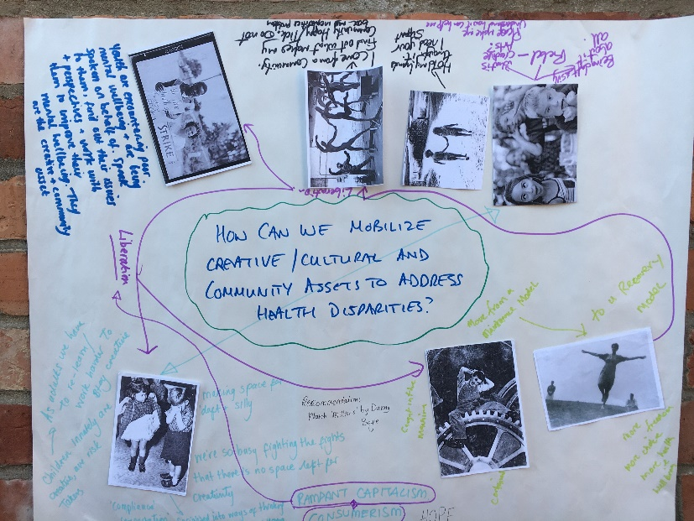
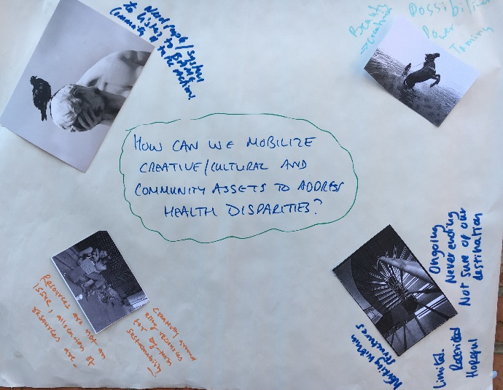
Poster 3
PIC 1: Need people/system to listen to BAME community and take action
Pic 2; Resources are not an issues, allocation of resources are, creativity around using resources for long terms sustainability
Pic 3: Possibilities, power, taming. Beauty_> creativism
Pic 4: Working within structures, ongoing , never ending, not sure of our destination, limited , restricted hopeful

Poster 4
Pic 1: Niche and the absolute ability to respond specifically to human complexity is key
Pic 2: But if we only ever see niche .. and not step back and see the full view of potential … we /the work will remain on the margins
Capturing imagination on a big scale
Pic 3: Imagination, escape, freedom, natural forces, friendship, brotherhood , dreaming
Pic 4: The most extraordinary community event that fills me with fear. Involving thousands across the world
Pic 5: Play – allowing interactions to evolve, create , flow, change – “yes, and ….”
Creating it together -fragility – has been ‘dismantled’ in many working class communities
Valuing relationships, being together, time – space and allowing things to emerge, not defining or controlling

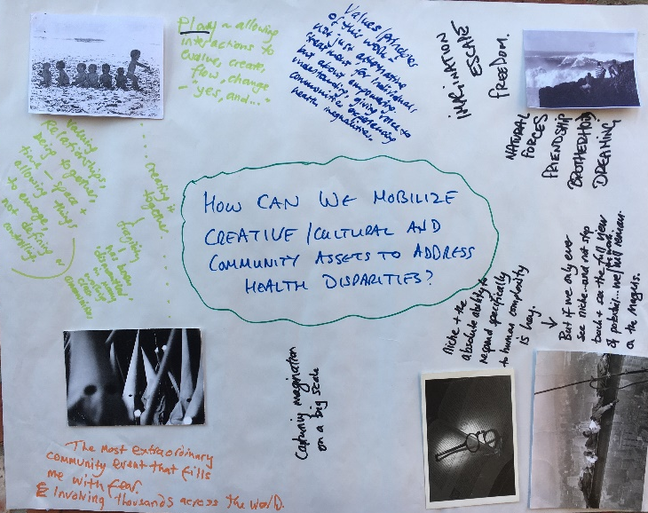

Poster 5
Pic 1: Critical shift re health professional attitudes
Picked because of the frustratingly slow/non-existent pace of change – the fact is that despite any work currently being undertaken by all in the room, health disparities are getting worse not better -> what needs to happen is long term widespread systemic and societal change … eg. funding systems not having to compete with each other ‘levelling up’ – te class structure, taxation …
Pic 2: A reminder that we live in a society where there is money – abundance of products
Utilize community spaces and people
Fairer funding system, core funding, streamline – reduce overall in offers, getting information to people
Pic 3: sharing food, stories in a community but all men in photo need to reach into different communities and work within their ???? – hope to expand more forward, shot experiences, widen/build trust
Harness and share knowledge and experience
National/regional strategy / action plan not 100s of project

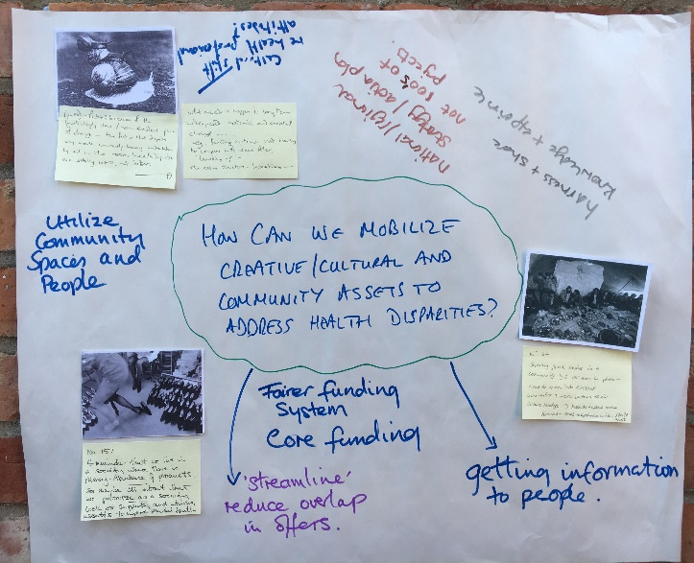

Poster 6
Pic 1: Bygone years, pride, safety, trust, collaborative nature
Pic 2: Mental health support for young men? Talking therapies are often accessed by females so how do we use creativity to support young men?
Pics 3(x3): shared experiences, community feeling, sense of belonging, support network, equal access, ..mixed skills
Pic 4: New experiences, shared learning, freedom, make mistakes (allowed), peer support safety
Pic 5: Look ! Things are moving fast, film, fun, nostalgia
Life is finite, we need to be aware of time, big view
Q: why is current investment not working
What’s the greatest causes - greating the widening gap
Time is running out
Where are the public health campaigns?

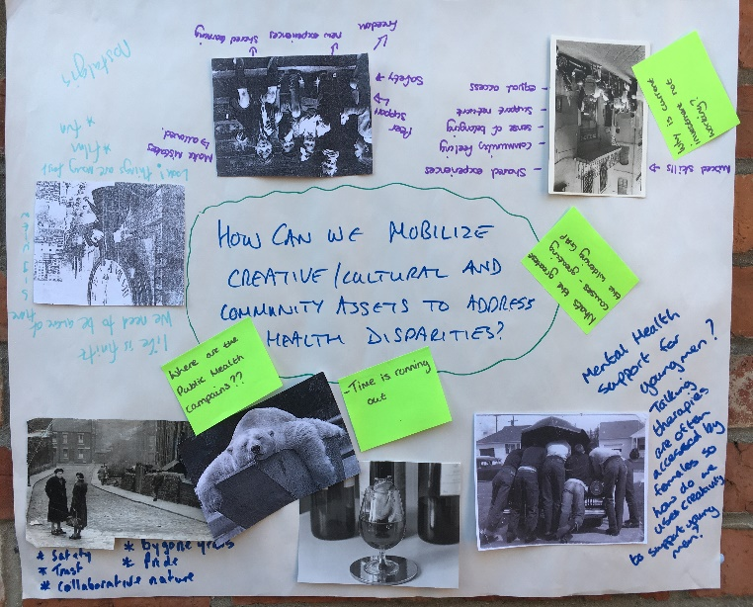

Poster 7
Pic 1: Celebrating art and creativity, seeing the joy; access for everyone, bring creative activity to public spaces
Embrace unpredictable outcomes; don’t underestimate the power of joy
Pic 2: Space for joy, unpredictable outcomes -> not pre-determined; an ecology of people supporting
Pic 3: Are we assuming we know what the problem is?
Pics 4 : Time for relaxing, boredom even? Space to think
Pic 5: Creativity can take you anywhere
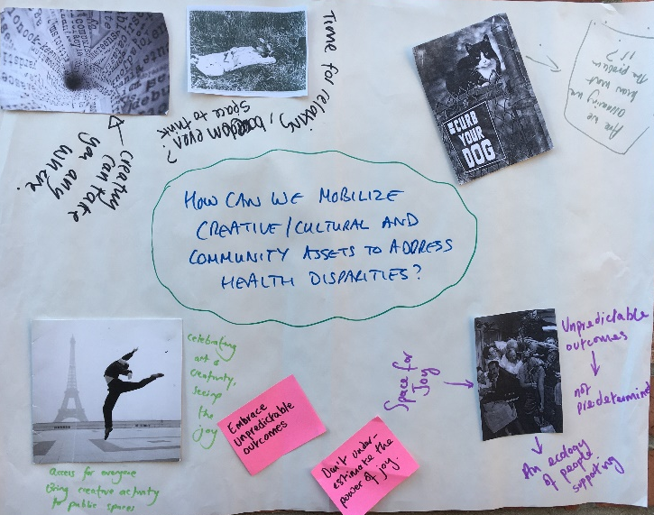
Pic1: Things were going fine until ….. How do I find the help I need to get out of this situation?
Emerging questions:… Find different ways to “walk alongside “ and offer choice, such as befriending service, how can we connect people to what is available?
Pic 2: People need choice
Pic 3: A blind cat helped by a sighted cat. Everyone has strengths/assets, befriending works, fund it!
Pic 4: Individual and community; opening up – bringing back the joy – impact on individual – virtuous circle- impact on community and development of communities
Pic 5: There is no right way home, it is different for everyone, people need lots of options and choices
Pic 6: Appearance can be deceptive – it might be a brutal landscape but scratch the surface and you will find amazing people and communities . … People have barriers in life. How can we help them get to where they want to be?

Poster 8
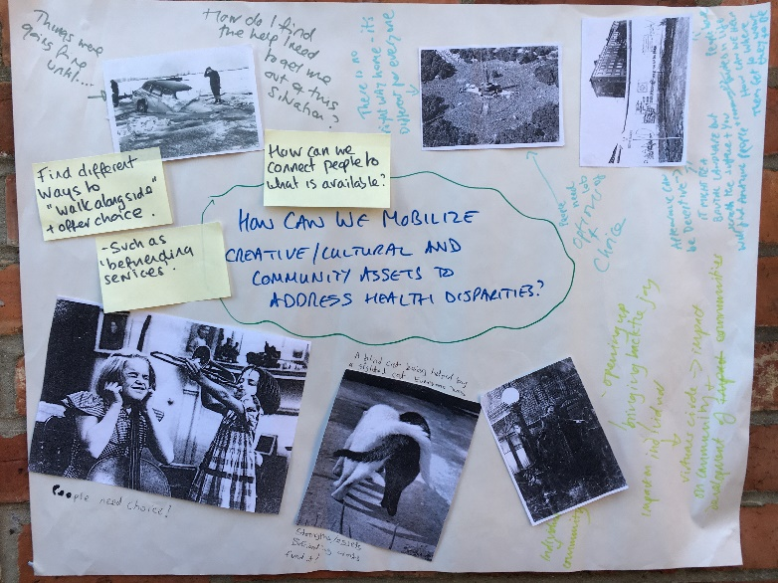

Poster 9
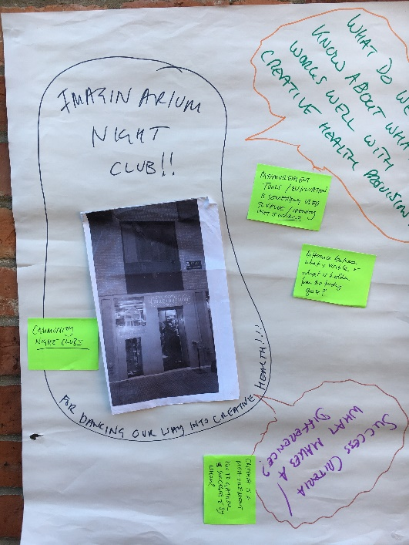
Pic 1: Imaginarium night club!! ..for dancing our way into creative health !!
- Community night clubs
- Difference between what is visible and hidden from the funding gaze

Summary of key learning for realising the value of creativity, cultural and community assets in responding to health disparities
Making space and time for creative engagement and possibilities to emerge, to speak and be listened to, for relaxing, for being bored, for wondering, not predefined or controlling, importance of ‘transitional’ public/community spaces, supporting the outliers.
Value of CCC assets realised gradually and organically, allowing problems and solutions to emerge, outcomes are unpredictable, is a journey, new experiences, making mistakes, shared learning, cocreating together.
Experientially realising the value of creativity – play, being silly, having fun, taking risks, creativity as a way of being to liberate rather than socialise compliance.
Human-centred – understanding individual issues and perspectives and work with people to improve wellbeing, getting below the surface, understanding complex human existence, everyone has strengths/assets.
Capturing imagination on a big scale, escape, freedom, dreaming, liberation, friendship.
Fun/play/variety/joy – interactions to enable creativity and change to happen, option and choices – different for everyone,
Utilizing community spaces and people, virtuous circle of communities and individuals, communities within communities - widen and build trust, sense of community / belonging, support network, befriending, nurturing relationships, being together.
Collaboration of cross sector, multi-agency partnership around common goals and priorities, creativity in use of resources … for long term sustainability -> regional strategy not 100s of short term projects, public health campaign, shifts in health service and professional attitudes, support for creative health workforce.
Measures of success need to be renegotiated to better reflect the complexities at play in a person’s journey towards accessing creative health.
Understanding how health disparities and inequalities are socially and environmentally determined; access to data to work with these wider social issues is part of the prevention package of health and social care.
Raising awareness and visibility of the creative/cultural and community assets in a place and working with these providers to address health inequalities.

