Title of Abstract in 24 Point Times New Roman Font

A.B. Smith*†, C.D. Jones‡ and E.F. Taylor§
†University of Alphatown, Street Name, Alphatown, 12345, United Kingdom
‡University of Betatown, Street Name, Betatown, 12345, United Kingdom
§University of Gammatown, Street Name, Gammatown, 12345, United Kingdom

*Corresponding author e-mail: j.a.hinks@hud.ac.uk

First paragraph of abstract. Text should be in 11 point Times New Roman and aligned left. The abstract length should be around 300 to 600 words but should not exceed one page in total including any figures and references.
Second and subsequent paragraphs should be indented like this one. Left margin is set to 3 cm to allow for binding and all other margins are set to 2 cm. Figure captions are aligned left and indented by 1 cm on both sides. References are optional [1] and should be numbered sequentially in square brackets like this [1–2].

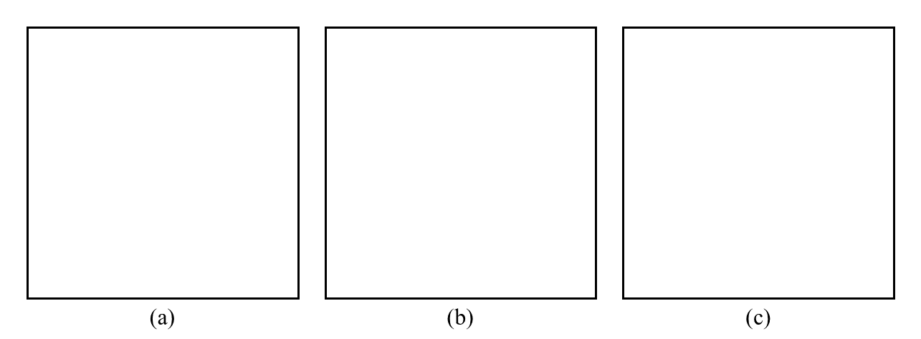
Figure 1: Figures for your abstract are optional but welcomed: (a) please ensure the resolution is of suitable quality for reproduction on-line and in print; (b) colour will be available in the on-line version only; and (c) be sure to reference the figure in the main text of your abstract.

References
[1] A.B. Smith, C.D. Jones and E.F. Taylor J. Nucl. Mater 498 (2017) p123
[2] C.B. Carter and D.B. Williams Transmission Electron Microscopy: A Textbook for Materials Science (Springer, New York, 2016)

