template and formatting instructions for ‘WHEN SOCIAL SCIENCE MEETs LEAN AND DIGITAL Technologies’ SHORT papers
Name Surname, Name Surname, and Name Surname

Abstract
This document describes how you should prepare your short paper to be submitted to the Scientific Committee of the 10th International Workshop When Social Science meets Lean and Digital Technologies. Correct formatting (e.g., using the set styles set in this template) is important to enable a swift production of the workshop proceedings. The abstract must have a maximum of 200 words, presenting in a single paragraph the following: 1 or 2 sentences with the background and research problem; 1 or 2 sentences with the aim and objectives of the paper; 1 or 2 sentences with the research method used; 1 or 2 sentences with current results and contributions of the paper, also including future research directions.
Keywords: Formatting, Instructions, Social Science, Lean and Digital Technologies, Template

Introduction
This document outlines the guidelines to write short papers for the workshop. It includes the graphic presentation (type and characters size, space between lines and paragraphs, formatting of tables and images) and structure. This document is formatted as required for your short paper. Therefore, authors can use this document as a model and should not change or amend the pre-defined styles.
The length of the short papers should be 4 pages, plus 1 page of references (therefore, 5 pages in total). Papers are expected to have a minimum of 3 pages.
The language for short papers is English; both UK English and American English are acceptable, but please select one and use it consistently. The short papers that do not follow these instructions will not be accepted for presentation in the workshop, nor published in the workshop proceedings.
Please present the background and context of the study in a clear and objective way in the introduction, as well as the research aims and objectives. You should also clearly present the research problem or gap.
The scientific committee expects that authors will follow the structure outlined in this template, which is aligned with the purpose of the workshop. It includes the introduction (current section), looking back, research method, future, and conclusions.

Looking Back
Participants of the workshop are encouraged to identify past research of relevance, and reflect on existing research related to the workshop central themes (i.e., Social Science, Lean and Digital Technologies) over the past ten years.
A significant body of literature exists to describe theory and applications as well as lean, digital technologies, and social sciences. Please build your arguments on existing research (or critique it). The literature review must be concise and contextualise the theoretical framework. Please also make sure to cite sources in the References section of the paper.

RESEARCH METHOD
This section should describe with sufficient details the research method adopted, as well as data collection and analysis techniques. As an example, if you used case studies, justify why this was the most appropriate method. If you used tools to collect data, like interviews, do describe briefly how many interviews were done, with whom, and what type of questions were asked. Please do describe the research design adopted. Please reference the text as appropriate.

results
Please describe your main research results, as well as the main contributions of the work.

Future
Participants of the workshop are encouraged to look forward and discuss current and future research trends and insights for future research.

Topic 1
The ‘Future’ section of the papers can explore the interaction between social science, Lean and digital technologies in the context of architecture, engineering, and construction.

Topic 2
The short papers can include figures and tables, such as Figure 1 and Table 1. Participants are required to use the formatting as per the examples below.
Figures should be inserted in the file by using the ‘Figure’ style, followed by a caption including the number of the Figure, adopting the ‘Figure caption’ style.
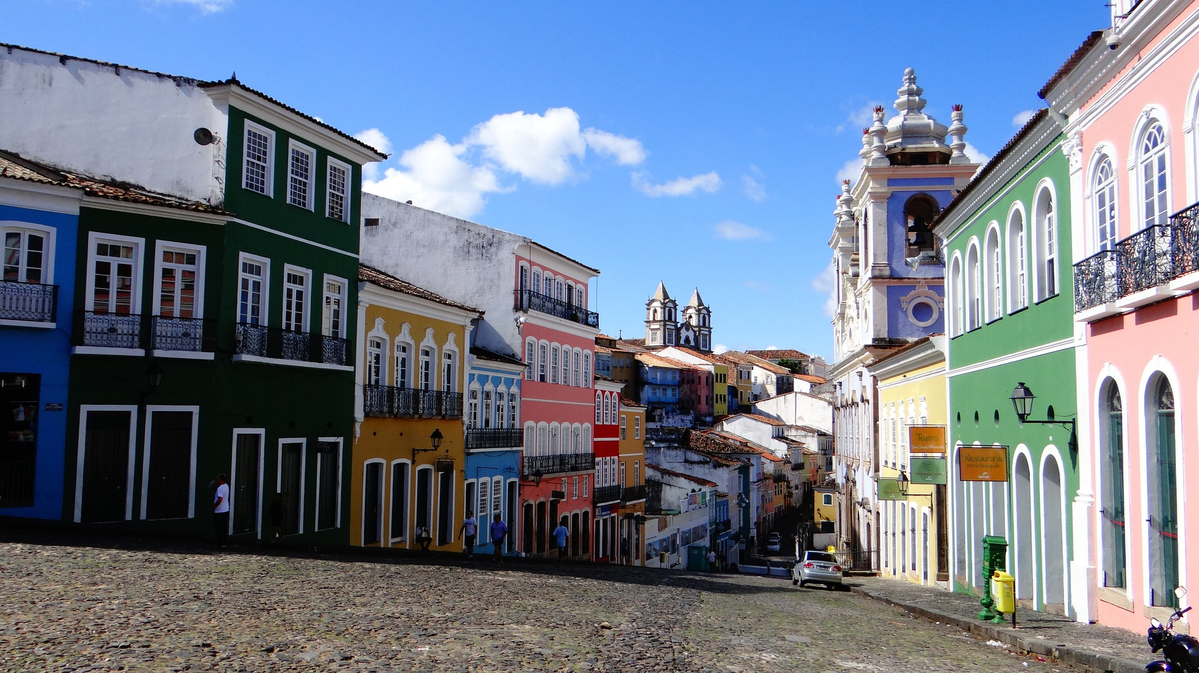
Figure 1: Pelourinho, Salvador
Tables should have a caption, following the ‘Table caption’ style, a thick top and bottom border, a thin border under headers and usually no vertical borders. The table contents should adopt the ‘Table body’ style, whereas the headings should be formatted according to the ‘Table Heading + Bold’ style. Table 1 provides an example.
Table 1: Table name
ID | Table heading
A | Table body
B | Table body
C | Table body
D | Table body
E | Table body

Conclusions
Please follow the instructions and formatting requirements presented in this document thoroughly.

Acknowledgments
In this section, you can acknowledge any further support or contribution in the development of the research work. This is not a mandatory section.

References
Please note that in this item only the references mentioned in the text should be listed. For formatting, see apastyle.apa.org/style-grammar-guidelines/references. The references should be formatted using the author-date format according to APA Style, Seventh Edition (apastyle.apa.org). The References section must include all work cited in the paper, sorted in alphabetical order by author.
Howell, G., Laufer, A., & Ballard, G. (1993). Interaction between subcycles: One key to improved methods. Journal of Construction Engineering and Management, 119(4), 714–728. https://doi.org/10.1061/(ASCE)0733-9364(1993)119:4(714)
March, S. T., & Smith, G. F. (1995). Design and natural science research on information technology. Decision Support Systems, 15(4), 251–266. https://doi.org/10.1016/0167-9236(94)00041-2
Sacks, R., Koskela, L., Dave, B. A., and Owen, R. (2010). Interaction of Lean and Building Information Modeling in Construction. Journal of Construction Engineering and Management, 136(9), 968–980.

Job role or position, Department name, School name, University name, Country, email, ORCID
Job role or position, Department name, School name, University name, Country, email, ORCID
Job role or position, Department name, School name, University name, Country, email, ORCID

